Course Code: CSE3150

Course Title: Front End Full Stack Development

Lab sheet 1 Javascript - Module 2

Problem Statement:
Ravi is trying to write a program in JavaScript to calculate the Fibonacci series of a given number and the square of a given number series as the assignment is given by class teacher, help Ravi to develop and demonstrate a HTML file that includes JavaScript script for the following problems:
a) Input: A number n obtained using prompt
Output: The first n Fibonacci numbers
b) Input: A number n obtained using prompt

Output: A table of numbers from 1 to n and their squares using alert

a)

<html>

<head>

<title>Fibonacci Series</title>

</head>

<body>

<script type="text/javascript">

var fib1=0,fib2=1,fib=0;

var num=prompt("Enter a number : \n", "");

if(num != null && num > 0 )

{

document.write("<h1>The first "+num+" numbers in the fibonacci series </h1>");

if(num==1)

document.write("<h2> "+ fib1 + "</h2>");

else

{

document.write("<h2>" + fib1 + "</h2>");

document.write("<h2>" + fib2 + "</h2>");

}

for(i=3;i<=num; i++)

{

fib= fib1 + fib2;

document.write("<h2> " + fib + "</h2>");

fib1=fib2;

fib2=fib;

}

}

else

alert("Invalid Input");

</script>

</body>

</html>

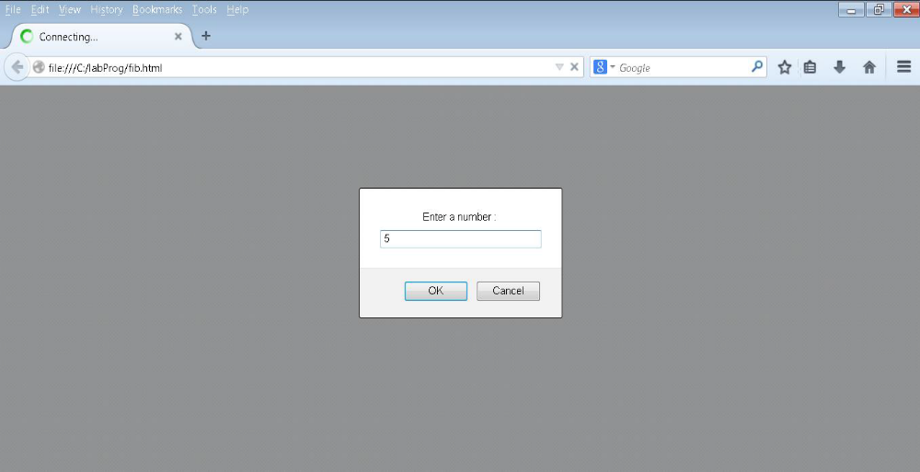

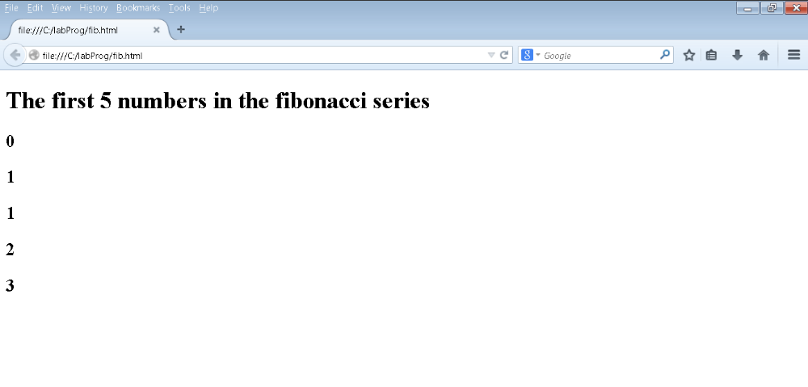

b) <!DOCTYPE html>

<html>

<head>

<title>Number and its squares</title>

</head>

<body>

<script type="text/javascript">

var num = prompt("Enter a number : \n", "");

var msgstr;

if(num > 0 && num !=null){

msgstr="Number and its Squares are \n";

for(i=1;i <= num; i++)

{

msgstr = msgstr + i + " ^ 2 = " + i*i + "\n";

}

alert(msgstr);

}

else

alert("Invalid Input");

</script>

</body>

</html>
